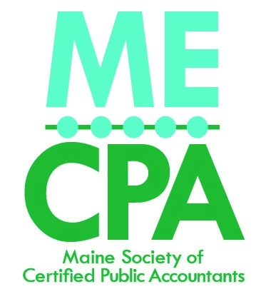

Key Highlights of NASBA & AICPA CPE Standards Update
Effective 1-1-2024

The National Association of State Boards of Accountancy (NASBA) and the American Institute of CPAs (AICPA) approved revisions to the Statement on Standards for Continuing Professional Education (CPE) Programs (Standards), as well as the NASBA Fields of Study document. The Standards changes, include additional options for virtual learning.
Among the most significant changes to the Standards is the addition of a virtual option under the Group Live instructional delivery method; clarifications to assist in the understanding of awarding CPE credit in appropriate increments, in the awarding of CPE credit when multiple presenters are actively involved in instructing one CPE program session, and in communicating and documenting the required attendance monitoring mechanisms for Group Internet Based programs.
See a redlined version of the Standards here to note the specific changes. CPE providers and program sponsors must comply with these Standards in order for credits to be “NASBA-certified”. The CPE programs offered by the MECPA, meet the requirements of the Maine Board of Accountancy, but do not, in all cases, meet NASBA certification.

