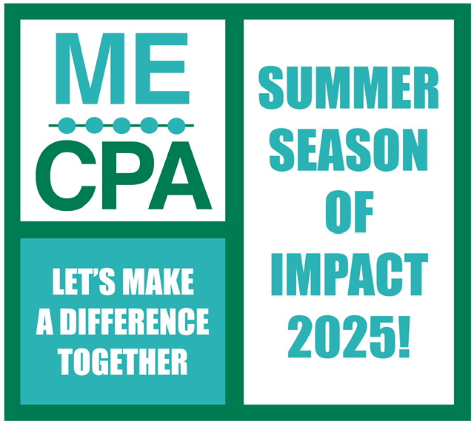

This summer we're challenging all companies, firms and individuals to help demonstrate to our communities what the MECPA already knows – that CPAs and accountants are very special people!
During our Summer Season of Impact campaign, simply keep track of your individual volunteer hours and document your activities by sharing photos with me or one of Difference Makers Committee Chairs – Kirin Schrum or Jordan Kennedy.
Volunteer hours at any Maine-based nonprofit can be tallied. Here are a few of our favorites:
Furniture Friends
Maine Center for Grieving Children
Maine Needs
Woodhouse Lighthouse Foundation
Our campaign runs through Sept. 3. Deadline for submitting your volunteer hour totals (email me) is Thursday, Sept. 4.
— Trish

